***Experiment # 4***

***Four stroke diesel ignition engine***

* **Introduction:**

It is an internal combustion engine or heat engine. In it chemical energy is converted into mechanical energy inside cylinder.

* **Process:**

1) Intake

2) Compression

3) Power

4) Exhaust

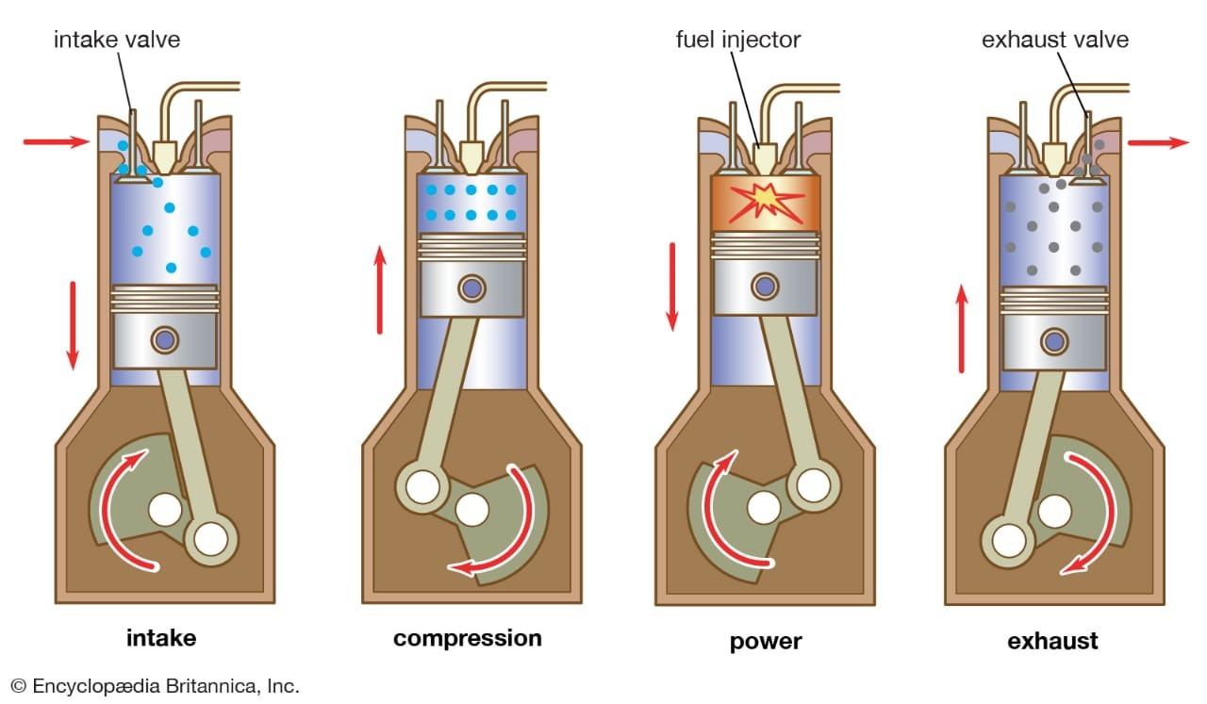

* **Intake:**

It is also known as induction or suction. This stroke of engine starts at top dead center and ends at bottom dead center. In this stroke the intake valve must be in open position while the piston pulls an air fuel mixture into the cylinder by creating vacuum pressure into the cylinder by the downward motion. The piston is moving down as air is being sucked in by the downward motion against the piston.

* **Compression:**

This stroke begins at B.D.C or just at the end of suction stroke and ends at B.D.C .In this stroke the piston compresses the air fuel mixture in preparation for ignition during the power stroke (below). Both the intake and exhaust valves are closed during this stage.

* **Combustion:**

Also known as power or ignition. This is the start of the second revolution of the four stroke cycle. At this point the crankshaft has completed a full 360 degree revolution. While the piston is at T.D.C. (the end of the compression stroke) the compressed air-fuel mixture is ignited by a [spark plug](mhtml:file://C:\Users\umarjattt\Documents\Four-stroke%20engine%20-%20Wikipedia(2).mhtml!https://en.m.wikipedia.org/wiki/Spark_plug) (in a gasoline engine) or by heat generated by high compression (diesel engines), forcefully returning the piston to B.D.C. This stroke produces mechanical work from the engine to turn the crankshaft.

* **Exhaust:**

Also known as outlet. During the *exhaust* stroke, the piston, once again, returns from B.D.C. to T.D.C. while the exhaust valve is open. This action expels the spent air-fuel mixture through the exhaust valve.These four strokes can be remembered by the colloquial phrase, "Suck, Squeeze, Bang, and Blow".

* **Labeled Diagram:**

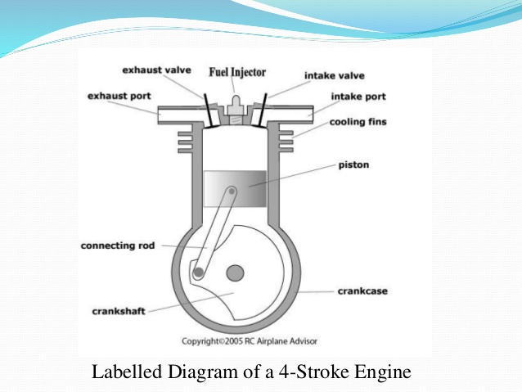

* **Parts of engine:**

1. Piston
2. Crankshaft
3. Crank case
4. Connecting rod
5. Cooling fins
6. Valves
7. Sump

* **Explanation of parts:**
* **Piston:**

It moves up and down and is a vital part of the cylinder. It comprises of different parts kike piston rings.

* **Crankshaft:**

The job of this part of diesel engine is to convert the up and down motion of the piston into rotational motion.

* **Valves:**

There are inlet and outlet valves in an engine. The inlet valves lat air and fuel into the engine and outlet valves let fumes out of the engine. When there is combustion and compression then both of these valves become closed. The combustion chamber remains closed at that time.

* **Connecting rod:**

The piston and crankshaft are connected by connecting rod.The power of rotation at both ends lets it change angles flexible as the crankshaft rotates and the piston moves.

* **Sump:**

The sump contains some oil and surrounds the crankshaft.

* **Crankcase:**

It encloses the crankshaft and crankshaft bearings. It is usually located at the bottom of the cylinder block. It directs returning oil into the oil pan.

* **Cooling fins:**

These fins keep the engine cool by providing a large contact to the outer air so as to achieve a better heat dissipation.

* **Applications:**

It is the most common type of internal combustion engine and is used in various automobiles like cars , trucks and buses.

* **Conclusion:**

I learnt about the working and different parts of four stroke diesel engine.